Civil war in Liberia

UNSC Resolution: | 1041
Date of adoption: | 29-Jan-1996
Operative paragraph: | 3
Demand number: | 1041,0311

Sarah-Myriam Martin-Brûlé

Wording of demand

respect and implement fully and expeditiously all the agreements and commitments they have already entered into, in particular the provisions of the Abuja Agreement with regard to the maintenance of the cease-fire, disarmament and demobilization of combatants, and national reconciliation

List of addressees of the demand

National Patriotic Front of Liberia, Government of Liberia, Central Revolutionary Council of the National Patriotic Front of Liberia, Lola Defence Force, Liberian National Conference, Liberian Peace Council, United Liberation Movement of Liberia for Democracy - Krahn, United Liberation Movement of Liberia for Democracy - Mandingo

Short-term compliance

Description of the addressee(s)’ conduct

“The Abuja Agreement remained largely unimplemented, hostilities were continuing, and the ceasefire and other measures called for by ECOWAS had not been honored. As a result, there was a breakdown of law and order, and the Council of State was unable to function since some of its members had left the country because their safety could not be
guaranteed. »
Chapter 8, « The Situation in Liberia »
http://www.un.org/Depts/dpa/repertoire/index.html

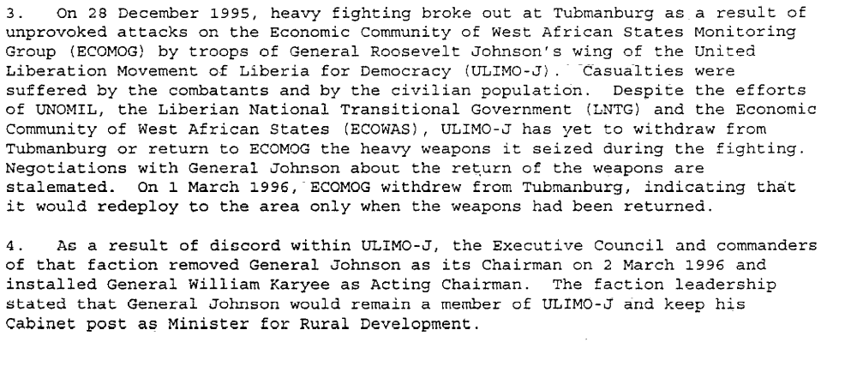

Sixteenth Progress Report of the Secretary-General on the United Nations Observer Mission in Liberia, S/1996/232, 1 April 1996

“(…) the Abuja I peace process did not progress (..) Despite the visible efforts to generate momentum amongst the international agencies and strengthen disarmament, demobilization and reintegration procedures, there was no movement toward peace between the warring factions, which, with few exceptions, did not disengage.” P. 84
(…) The result of this continued distrust and confrontation was that the other phases that were to follow disengagement, such as the assembly, encampment and disarmament and demobilization phases could not begin. (….)( Alao, Mackinlay & Olonisakin 1999: 85)
(…) In many respects, the progress achieved in the phases of the disarmament and demobilization process was cosmetic. Although a structure was put in place, with procedures and task properly delineated, in practice, plans to implement this process were absent. (Alao, Mackinlay & Olonisakin 1999: 86)
(…)The fact that the implementation of the first Abuja Agreement was halted by more cease-fire violations revealed that the entire peace process was absolutely dependent on the desire of the conflicting parties to see them succeed. P.87
(…)the warring parties failed to make the concessions needed to underpin a workable peace process. (Alao, Mackinlay & Olonisakin 1999: 87)

Abiodun Alao, John Mackinlay, Funmi Olonisaki. 1999. Peacekeepers, Politicians and Warlords: the Liberian Peace Process. United Nations University Press.

Assessment

Short-term compliance
X No or marginal compliance (1) | Medium low compliance (2) | Medium high compliance (3) | Full or almost full compliance (4)

Considerations underlying the assessment
Within the first six months the demand addressees did not respect and implement fully and expeditiously all the agreements and commitments they have already entered into, in particular the provisions of the Abuja Agreement with regard to the maintenance of the cease-fire, disarmament and demobilization of combatants, and national reconciliation.

Medium-term compliance

Description of the addressee(s)’ conduct

After the collapse of Abuja I, attempts to restore the momentum of the peace process in Liberia resulted in the extension of the Abuja Agreement of August 1995 with a revised schedule of implementation. The extended Abuja Agreement (referred to as Abuja II) was signed in Abuja on 17 August 199. Despite the serious challenges which had dereailed the preceding arrangement and the emergence of new ones, this agreement was implemented and resulted in the disarmament of about 23,000 combatants, something that had seemed impossible only a few months earlier. (Alao, Mackinlay & Olonisakin 1999: 90)

(…)
“ the extent of the demobilization by the two warring leaders (..) Taylor (NPFL) and Kromah (ULIMO-K) was particularly impressive. Despite the fact that the two leaders controlled an estimated 60% of the fighters, they accounted for 84% of the disarmed fighters. (Alao, Mackinlay & Olonisakin 1999: 100)

Abiodun Alao, John Mackinlay, Funmi Olonisakin. 1999.Peacekeepers, Politicians and Warlords: The Liberian Peace Process. United Nations University Press

Assessment

Medium-term compliance
No or marginal compliance (1) | Medium low compliance (2) | X Medium high compliance (3) | Full or almost full compliance (4)

Considerations underlying the assessment

Within the two years following the adoption of the resolution, the parties complied with almost all aspects of the demand (cease-fire, disarmament, and demobilization of combatants) which were highly significant to the achievement of the objectives of the demand.

Depth of demand

Assessment

Level of depth of demand
Low depth of demand (1) | Medium depth of demand (2) | X High depth of demand (3)

Considerations underlying the assessment

In the absence of a guarantee of compliance by the other demand addressees, compliance with this demand put the survival of the demand addressees at risk. Alao, Mackinlay and Olonisakin (1999) offer the following explanation:

“A number of factors accounted for the slump in progress. First, the fighters mistrusted each other. In Zwedru, for example, the LPC was reluctant to disarm because it knew that the NPFL was maintaining a group of fighters just outside the area. In Voinjama, the ULIMO-K voluntarily disarmed in September 1996 and was attacked by bandits shortly afterward. ULIMO-J complained that , in Tubmanburg, some fighters were attacked on returning to their village following disarmament and demobilization. The possibility of being vulnerable to attack by other fighters led many to hold on to their weapons (…) . Second, many fighters were discouraged by the fact that they had to walk long distances before reaching disarmament sites. Third factions commanders remaining in the field were personally reluctant to disarm. Many of them were unsure of their future and thus prevented fighters under their control from disarming. In some cases, fighters were threatened with severe punishment if they disarmed individually without permission.” (Alao, Mackinlay & Olonisakin 1999: 98)
Abiodun Alao, John Mackinlay, Funmi Olonisakin. 1999.Peacekeepers, Politicians and Warlords: The Liberian Peace Process. United Nations University Press

Level of confidence about coding decisions

Level of confidence about coding decision
Extremely high | X High | Moderate

Comments to IPI (if any)

